Project Management Plan

Oxygen Thieves

Version 3.0

**Version Control**

**1.0 - Draft** **8/28/22**

**1.5 - Demo 1** **10/21/22**

**2.0 - Demo 2& revised documentation** **11/8/22**

**3.0 - Final Demo & documentation** **12/7/22**

**Executive Summary**

The Thompson Project is a primary destination for at-risk youth providing mentorship, entertainment clothing and more. However, the project needs to satisfy the current business needs such as Increasing revenue for future expansion, improved publicity, streamlining of volunteer process and improving access to information of the organization.

The business requirements of the Thompson Project will be satisfied by providing technical infrastructure and support via website that contains all processes required to efficiently interact with the organization which will fulfill business needs. Utilization of a content management system, WordPress in our case, will allow for the following content within the site to be streamlined, however not limited to:

* Data storage
* Donation functionality
* General information/ About Us for organizations mission and goals
* Volunteers sign up & training
* Integration of social media platforms to raise publicity and awareness of the organization

**Statement of Work**

This statement of work is entered into by and between the undersigned Buyer and Service Provider pursuant to the Project Services Agreement (the “**Agreement**”) governing the following Project: Website Building and describes project scope along with performance, design expectations and responsibilities between the client and team. Check out the full Statement of work below:



**Project Charter**

This project charter will serve to provide a brief overview of the project, including general information, team member information, stakeholder information, and project scope details.



**WBS**

Work breakdown structure is a deliverable focused on breaking down the project into smaller components. This breakdown manages and organizes the teams work into reasonable sections that makes the project process easy to follow. Our WBS document for the Thompson project outlines all processes involved and breaks it down into responsibilities, goals and objectives met for the product.

**Phase View**

Phase view gives you a layout and scope of how the project was conducted in sequential order of the process. The Thompson Project had 4 major phases as it started with initiating the project and ended with roll out and support.

**Product View**

The WBS product view gives you a straightforward screen layout style view of what is presented within the website itself. These are listed in order of what's presented on each page and the order in which they were completed.

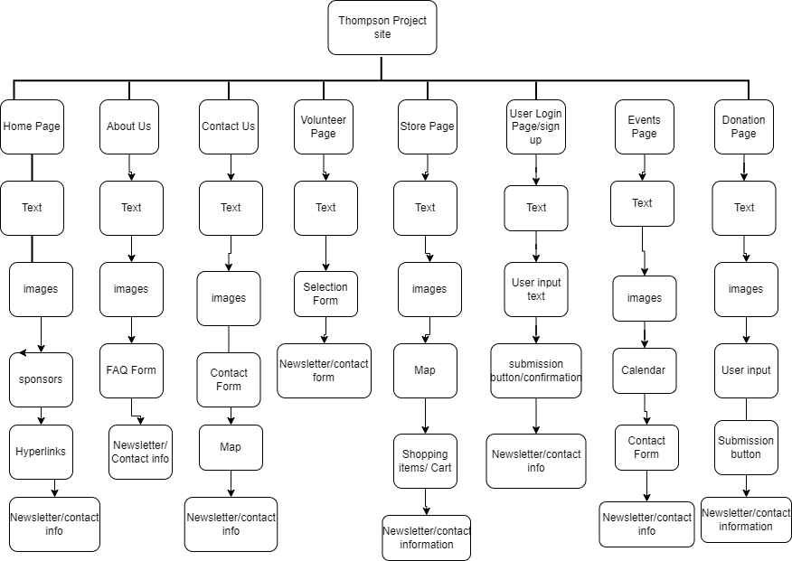

**WBS Dictionary**

This is a central location where all tasks, activities, and deliverables related to the project reside. Each task related to the Thompson Project is shown in the order in which they were completed/ in phase format to ensure authenticity in our process.



**Project Schedule / Workstream**

The Project schedule serves as a baseline for all the main objectives and tasks our team was to complete. Each main objective is listed below the corresponding weeks that our team spent working. It is displayed in a GAANT chart format below.

**ERD**

Entity relationship diagram describes the relationship between people, objects, places concepts and events within the Thompson project in a graphical format. The ERD uses this framework display to represent how each entity in the process interacts with each other on the backend to display what the end user sees on the front end.

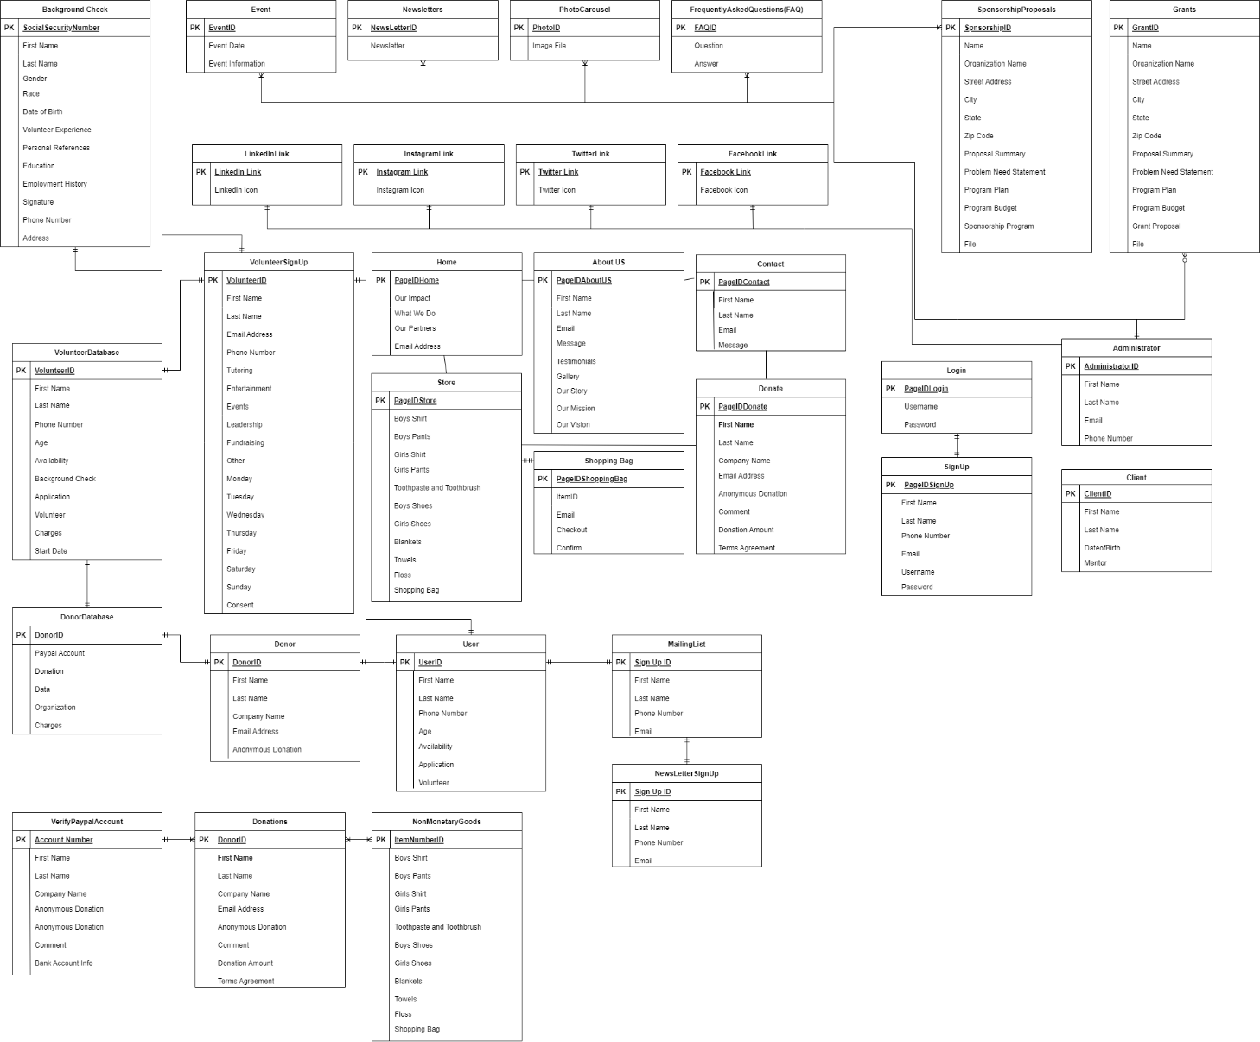

**User Flow Diagram**

A user flow diagram is a chart or diagram showing the path a user will take in an application to complete a task. A user flow diagram gives us an understanding of how users interact with our website and the steps they will take to achieve a certain task. It helps with creating a better user experience and helps meet user needs more efficiently. Developers can also use user flow diagrams to gain a better understanding of what features need to be implemented and how to do so. Diagram

**System Architecture Design**

The process begins with the User PCs which access the application server through the firewall we will have in place. We will eventually determine the specific systems and servers that will be used. We will utilize a database to store donor and volunteer information. This will be backed up through the clouds. We will use a content management system to form the website and integrate a payment management system for donations.

**Requirements Management Plan / Requirements**

The Requirements Management Plan (RMP) consists of 3 versions, with version 1.2 being the final. The RMP contains the original project overview as well as the functional and non-functional requirements given to us at project inception. More have been added as needed. All other scheduling information is presented on an as needed basis for the future.



**Budget:**

This final budget outlines the monthly costs of our website in total. The WordPress business plan was our plan of choice since it already includes many needed features with the included plugins. The total cost of WordPress Business is $25 a month, with all alternative plans listed. Our payment system of choice, PayPal, has minimal fees that can be further reduced by registering as a non-profit organization.

|  |
| --- |
| BUDGET INFORMATION |
| * Sources of revenue: Grants, Donations, & Fundraisers * WordPress Personal: $4 * WordPress Premium: $8 * **WordPress Business: $25** * WordPress eCommerce $45 * Business PayPal: 2.89% + $0.49 per domestic transaction * Non-profit PayPal: 2.2% + $0.30 per domestic transaction |

**Requirement Traceability Matrix**

This document maps and traces user requirements with test cases. The following matrix is listed below (click icon):

The Requirement Traceability Matrix has all the user requirements that were a part of the developing process of the project. This document was used to keep track of our progress with each requirement during the project and how they were implemented into our website exactly. Our project plans did not change much and only a few requirements ended up not being done due to changes. For further organization, we decided to input who was responsible for each of the requirements and how important the requirement so that we knew which ones to work on first.



**Stakeholder Management/Communication Plan**

Communication matrix describes all processes involved on a weekly basis for completing objectives and goals of the Thompson Project. This document outlines all expectations, standards and procedures that will be followed along with the frequency and target audience of each deliverable within the project. The Progress report outlines all requirements that were met and the status of the project, outlining all risks, budget, executive summary, and next steps. Check the documents below to view the communication plan and progress reports of the Thompson Project.





**Stakeholder Register**

This document is a register of all parties involved in the process of the Thompson Project and the roles associated with each member. Specifics on certain role changes or stakeholders can be updated here in this file. Check the document below for our full stakeholder register list.

